ComicCraft – AI Comic Story Creator powered by Gemini & Stable Diffusion
Final Project Report
Date | 29/09/2026
Team ID | SWTID-2026-1512
Project Name | ComicCraft

Team Leader: LAKSHMIPRIYA M | Team Members: KAVIYA K, KIRTHANA, KOWSALYA M

Description
ComicCraft is an AI-powered web application that helps anyone turn a short story idea into a finished comic. Built using Python, FastAPI, and Jinja2, the application accepts a story prompt together with a character name, setting, tone, art style, and panel count. It then produces a comic outline, panel descriptions, narration, dialogue, image prompts, panel images, a complete comic layout, and a downloadable PDF.
Text generation is performed by Google Gemini in two stages. In the first stage the model acts as a storyboard writer and produces a titled outline with a scene and an image prompt for every panel. In the second stage it acts as a comic script writer and expands the outline into a caption, narration, and short dialogue for each panel.
Artwork is produced by an image generator that supports two modes. Placeholder mode creates simple labelled images with Pillow so the whole application can be tested quickly without downloading a large model. Diffusers mode uses Hugging Face Diffusers and Stable Diffusion to create real AI illustrations for each panel.
The application follows a modular service structure. Request validation is handled by Pydantic, settings are loaded from a .env file, and the finished comic is displayed on a preview page and exported to PDF with FPDF2. A JSON API endpoint makes the same functionality available to other applications.

Scenario-Based Case Study

Background
Arun is a college student who loves science-fiction stories. He often imagines characters and adventures, such as a student who discovers a mysterious robot in a futuristic college laboratory. He would like to share these stories as comics, but he cannot draw and has never written a panel-by-panel script.

Problem
- Creating a comic needs writing, scripting, and illustration skills at the same time.
- Hiring an artist or writer is expensive and slow.
- Existing tools provide either text or images, not a complete structured comic.
- It is difficult to keep the story, dialogue, and visuals consistent.
- There is no simple way to produce a shareable or printable result.

Solution
ComicCraft gives Arun a single web form. He describes the story, names the main character, picks the setting, tone, and art style, and chooses how many panels he wants. Gemini plans and writes the comic, the image generator draws every panel, and the application shows the result in the browser. Arun can then download the complete comic as a PDF and share it with his friends.

Usage

User Usage
A user opens the home page and fills in the story form. After clicking Create My Comic, the button changes to a loading state while the comic is generated. When generation finishes, the preview page displays the comic title and every panel with its image, caption, scene description, narration, and dialogue. A Download PDF button is provided at the top and bottom of the page.
Developers can also call the JSON endpoint POST /generate-comic/json with the same fields and receive the comic as structured data.

AI Usage
The AI modules communicate with Google Gemini through the google-genai client. The user provides:
- Story idea
- Main character
- Setting
- Tone (for example Adventurous, Funny, Mysterious)
- Art style (for example Cinematic comic book, Anime comic, Manga)
- Number of panels (3, 4, or 5)
Gemini returns:
- A comic title and panel-by-panel outline
- Scene description for every panel
- Caption, narration, and short dialogue
- A detailed image prompt describing characters, environment, lighting, composition, emotion, and comic style
Each image prompt is then passed to the image generator to create the panel artwork.

Outcome
ComicCraft significantly reduces the effort of creating a comic. A user with no artistic training can obtain a structured story, artwork, and a PDF from a single short description. The modular architecture keeps the code easy to maintain and allows new models, art styles, and output formats to be added without major redesign.
The application can later be extended with user accounts, a saved comic library, speech bubbles drawn on the images, consistent characters across panels, multi-language support, and background job processing.

1. Software Requirements
ComicCraft requires the following software components for development and execution.
- Operating System: Windows 10/11, macOS, or Linux.
- Python (3.11 recommended): Runtime for the FastAPI application.
- pip and venv: Package installation and virtual environments.
- FastAPI and Uvicorn: Web framework and ASGI server.
- Jinja2: HTML template rendering.
- Pydantic, pydantic-settings, python-dotenv: Validation and configuration.
- google-genai: Client library for the Google Gemini API.
- Pillow: Placeholder image creation.
- FPDF2: PDF export.
- Hugging Face Diffusers and PyTorch (optional): Real Stable Diffusion image generation.
- pytest: Automated testing.
- Code Editor: Visual Studio Code or a similar IDE.

2. Hardware Requirements
- Processor: Intel Core i5 (8th Gen or above) / AMD Ryzen 5 or equivalent.
- RAM: 8 GB minimum (16 GB recommended when running Stable Diffusion).
- GPU: Optional in placeholder mode; strongly recommended for practical Stable Diffusion image generation.
- Storage: 1 GB for the application; several additional GB if the Stable Diffusion model is downloaded.
- Internet: Required for Gemini API calls and for the first model download.

Epic 1: Project Architecture
ComicCraft follows a layered architecture. The browser sends a request to the FastAPI server. The routes validate the input and run the comic creation pipeline, which calls independent service modules one after another. Templates render the results, and generated files are kept in the static folder.
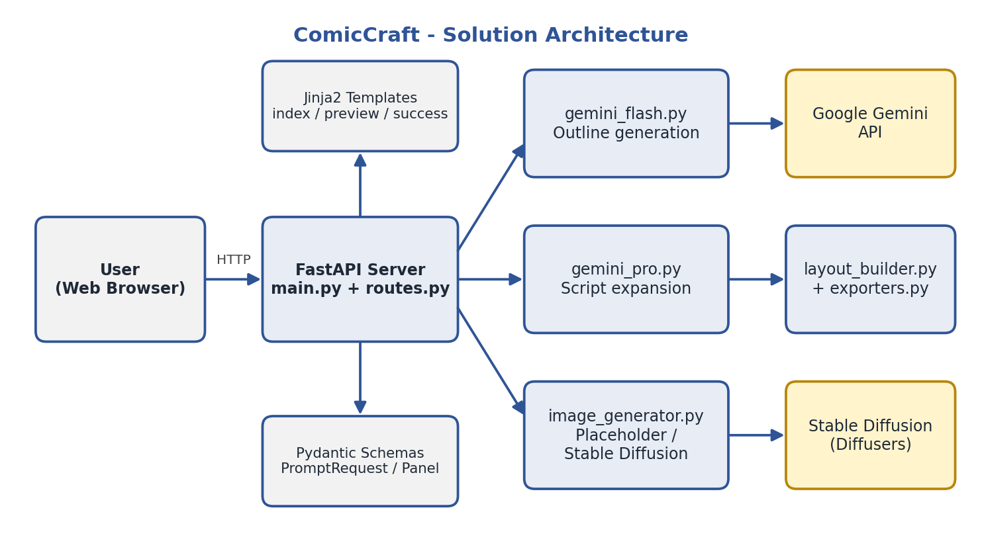
Figure 1: ComicCraft technical architecture

Overall Architecture Components
- Client (web browser or API client)
- FastAPI server and routes
- Pydantic schemas
- Gemini outline service
- Gemini script service
- Image generator
- Layout builder
- PDF exporter
- Jinja2 templates and static files

Components Definition

1. Client Layer
The client is a web browser that displays the story form, the loading state, the comic preview, and the download link. Developers may also use tools such as Postman or Swagger UI (/docs) to call the JSON API.

2. FastAPI Server (main.py)
Creates the application, mounts the static directory, configures the Jinja2 templates, registers the router, and provides the /health endpoint.

3. Route Layer (routes.py)
- GET / — shows the story form
- POST /generate — creates a comic from the form and shows the preview
- POST /generate-comic/json — creates a comic and returns JSON
- GET /export-success — shows a PDF export success page
- GET /test-image — generates a test image for diagnostics
The create_comic function contains the pipeline: outline → script → panel images → layout → PDF.

4. Schema Layer (schemas.py)
PromptRequest validates user input (story prompt at least 3 characters, panel count between 3 and 5). Panel and ComicResult describe the structure of the generated comic.

5. Gemini Services
- gemini_flash.py: builds the storyboard prompt, requests JSON, extracts and validates the outline.
- gemini_pro.py: expands the outline into caption, narration, dialogue, and image prompt for each panel.

6. Image Generator (image_generator.py)
Creates one PNG per panel. In placeholder mode it draws a bordered image containing the panel number and prompt text. In diffusers mode it loads the Stable Diffusion pipeline on first use (GPU if available, CPU otherwise) and generates the image from the prompt.

7. Layout Builder and Exporter
layout_builder.py merges the story panels with their image URLs into one comic structure. exporters.py writes a PDF with a title, the panel image, and the scene, caption, narration, and dialogue text for each panel.

Data Model Description
ComicCraft does not use a database. Data is represented by Pydantic models while a request is processed, and generated files are stored in the file system.

1. PromptRequest
Field | Type | Description
story_prompt | String (min 3 characters) | Main comic story idea
character_name | String | Name of the main character (default: Alex)
setting | String | Where the story takes place
tone | String | Mood of the story (default: Adventurous)
art_style | String | Visual style (default: Cinematic comic book)
panel_count | Integer (3–5) | Number of panels (default: 5)

2. Panel
Field | Type | Description
panel_number | Integer | Position of the panel
scene | String | Visual description of what happens
caption | String | Short caption
narration | String | Narration text
dialogue | String | Spoken dialogue
image_prompt | String | Prompt sent to the image generator
image_url | String | URL of the generated panel image

3. ComicResult
Contains the comic title, the list of panels, and the pdf_url of the exported PDF.

Stored Files
- static/panels/ — generated panel images (PNG)
- static/exports/ — exported comic PDFs

Key Features

1. Story Input
A simple form collects the story idea, character, setting, tone, art style, and number of panels.

2. AI Story Generation
Gemini creates a structured outline and then a complete script with caption, narration, and dialogue for each panel.

3. AI Image Generation
Stable Diffusion creates artwork from Gemini's image prompts. A placeholder mode allows quick testing without any model download.

4. Comic Preview
The result is displayed panel by panel in the browser.

5. PDF Export
The complete comic is exported as a PDF with one page per panel.

6. JSON API
The endpoint POST /generate-comic/json returns the complete comic data for use by other applications.

7. Robust AI Response Handling
The services extract JSON even when the model wraps it in Markdown fences, and verify that the number of panels matches the request.

8. Configurable Environment
Models, image provider, image size, and inference steps can be changed through the .env file without editing code.

Roles and Responsibilities
ComicCraft supports one primary role.

Creator (Visitor)
- Enter story details.
- Choose tone, art style, and panel count.
- Generate the comic.
- Review the preview.
- Download the PDF.
- Call the JSON API (developers).

User Flow
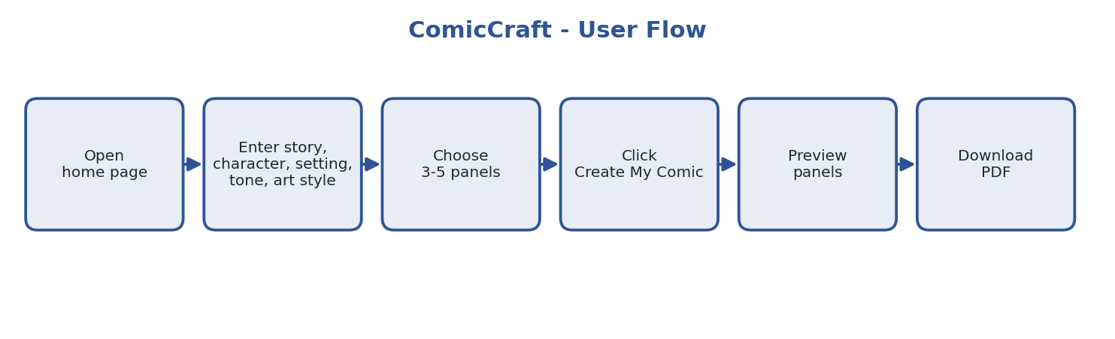
Figure 2: ComicCraft user flow
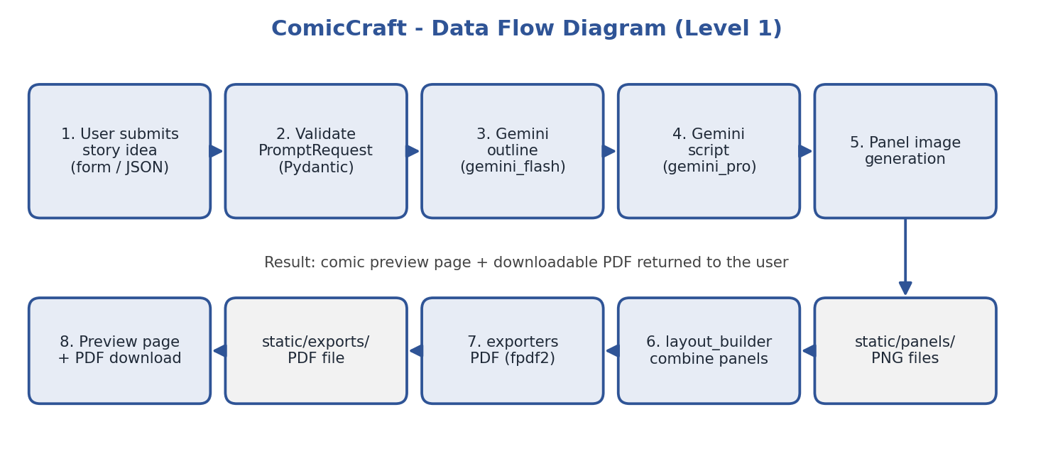
Figure 3: ComicCraft data flow diagram

Application Architecture Pattern
ComicCraft uses a service-oriented layering that is similar to MVC:
- Model layer: Pydantic schemas and generated data.
- View layer: Jinja2 templates with CSS and JavaScript.
- Controller layer: FastAPI routes that run the pipeline.
- Service layer: Gemini services, image generator, layout builder, and exporter.
This separation gives loose coupling, simpler testing, and easier extension.

Epic 2: Project Setup and Configuration

Creating the Project Folder
Step 1: Create a folder named ComicCraft and open it in Visual Studio Code.
Step 2: Create the folders app, app/services, templates, static/css, static/js, static/panels, static/exports, and tests.
Step 3: Create and activate a virtual environment:
python -m venv .venv
.venv\Scripts\activate

Step 4: Install the dependencies listed in requirements.txt:
pip install -r requirements.txt

The main packages are fastapi, uvicorn[standard], jinja2, python-multipart, pydantic, pydantic-settings, python-dotenv, google-genai, Pillow, fpdf2, and pytest.

Environment Variables
Sensitive information is stored in the .env file, which is created by copying .env.example.
GEMINI_API_KEY=your_google_gemini_api_key_here
GEMINI_OUTLINE_MODEL=gemini-2.5-flash
GEMINI_STORY_MODEL=gemini-2.5-flash
HF_TOKEN=
IMAGE_PROVIDER=placeholder
IMAGE_MODEL=stable-diffusion-v1-5/stable-diffusion-v1-5
IMAGE_WIDTH=512
IMAGE_HEIGHT=512
IMAGE_STEPS=20

Never upload the .env file to GitHub and never expose the Gemini API key publicly. For the first local test, keep IMAGE_PROVIDER=placeholder.

Epic 3: Backend Development
The backend consists of the following modules:
- Configuration (config.py) and schemas (schemas.py)
- Gemini outline service and Gemini script service
- Image generator
- Layout builder and PDF exporter
- Routes and application entry point (main.py)

Gemini Outline Service
The service builds a prompt asking Gemini to act as a professional comic storyboard writer and to return only valid JSON with a title and exactly the requested number of panels. The reply is cleaned, parsed, and checked; missing fields receive defaults.

Gemini Script Service
The outline is sent to Gemini again with instructions to act as a comic-book script writer. Dialogue must be short enough for a comic panel, captions concise, and narration must move the story forward. The service verifies the panel count and fills missing fields.

Image Generation
Depending on IMAGE_PROVIDER, the generator either draws a placeholder image or runs Stable Diffusion. Any other provider value raises an error.

Layout and Export
The layout builder returns the final comic dictionary. The exporter writes a uniquely named PDF file and returns its URL.

Epic 4: Frontend Development
The user interface is built with HTML templates rendered by Jinja2 and styled with a single CSS file.
- index.html: hero section, story form, error box, and a four-step pipeline explanation (Idea → Gemini → AI Art → PDF).
- comic_preview.html: comic title, download buttons, and a grid of panel cards.
- export_success.html: confirmation page with a download link.
- script.js: disables the submit button and shows a loading message while the comic is being generated.

Epic 5: Project Execution
Start the application from the project folder:
uvicorn app.main:app --reload

- Open http://127.0.0.1:8000 to use the application.
- Open http://127.0.0.1:8000/docs for the interactive API documentation.
- Open http://127.0.0.1:8000/health to verify that the server is running.
- Open http://127.0.0.1:8000/test-image to test image generation.
Run the automated tests with:
pytest -q

Sample JSON Request
POST /generate-comic/json
{
"story_prompt": "A student discovers a mysterious robot.",
"character_name": "Arun",
"setting": "A futuristic college laboratory",
"tone": "Adventurous",
"art_style": "Cinematic comic book",
"panel_count": 5
}

Sample Output (placeholder mode)
The image below is a panel generated by the application in placeholder mode.
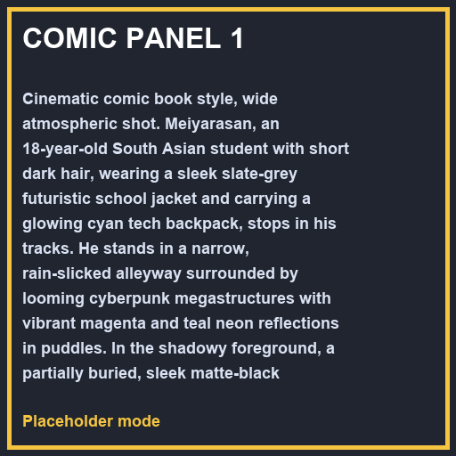
Figure 4: Sample panel generated in placeholder mode

Real AI Image Generation
After confirming that the application works in placeholder mode, change IMAGE_PROVIDER=placeholder to IMAGE_PROVIDER=diffusers in .env. The first generation takes noticeably longer because the Stable Diffusion model must be downloaded and loaded, and a GPU is strongly recommended.

Epic 6: Testing
Testing is performed with pytest and with manual end-to-end checks. Automated tests verify that the /health endpoint returns status "ok" and that the home page contains the ComicCraft name. Manual tests cover comic generation with 3, 4, and 5 panels, PDF download, the JSON endpoint, validation errors, and behaviour when the API key is missing. Detailed test cases and the bug log are provided in the User Acceptance Testing document.

Demo Video Link:
[Add demo video link here]

